**Task 2: Active Directory Implementation**

**Servers Configuration.**

* **Create a New Virtual Machine.**

I will create an empty virtual machine where a new Windows Server 2019 Standard will be installed.

To create a new virtual machine in Hyper-V, perform the following steps.

From **Server Manager Dashboard**window, click **Tools**menu and select **Hyper-V Manager**.

The **Hyper-V Manager**window opens.

Click on PLABDM01server to see other guest virtual machines.

Right-click on PLABDM01and select **New**> **Virtual Machine**…

The **New Virtual Machine Wizard**window opens.

On the **Before you begin**page, click **Next.**

On the **Specify Name and Location**page, click in the Name and I name it **WaberiProject.**

On the **Specify Generation**page, verify that **Generation 1**option is selected.

Click **Next**.

On the **Assign Memory**page, **Startup Memory**is set by default to **1024**MB.

Keep the default specification.

Click **Next**.

On the **Configure Networking**page, change **Connection**drop-down list to **Microsoft Hyper-V Network Adapter - Virtual Switch**.

Click **Next**.

On the **Connect Virtual Hard Disk**page, keep the default specification.

Click **Next**.

On the **Installation Options**, select **Install an operating system from a bootable CD/DVD-ROM**option button**.**

On the **Image file (iso)** drop-down the ISO image.

Click **Next**.

On the **Completing the New Virtual Machine Wizard**page, a description summarizing the details of the new virtual machine is displayed.

Click **Finish**.

You are directed back to **Hyper-V Manager**. Notice the new virtual machine **WaberiProject**is now created.

You will install Windows Server 2019 Standard on this new VM in the succeeding task.

* **Install Windows Server 2019 Standard**

Ensure you are connected to **PLABDM01**. The Hyper-V Manager window is open.

Right-click on **WaberiProject** virtual machine and select Connect…

The **WaberiProject** on **PLABDM01** - **Virtual Machine Connection** window is open.

Click **Start,** button to power on this device.

Please wait while the virtual machine is starting up.

The **WaberiProject on PLABDM01**connection bar is displayed.

On the **Windows Setup**screen, accept the default locale and click **Next**.

On the **Windows Setup**screen, click **Install now**.

Please wait while setup is starting. This will take a few moments.

On the **Select the operating system you want to install**page; the **Windows Server 2019 Standard (Desktop Experience)**is selected for you.

Click **Next**.

On the **License Terms**page, select the **I accept the license terms**checkbox.

Click **Next**.

On the “**Which type of installation do you want?”**page, click **Custom: Install Windows only (advanced).**

On the “**Where do you want to install Windows**?” page, click **Next**.

On the **Installing Windows**page, installation of the operating system begins.

Please wait as this will take a few minutes to configure.

Once the installation finishes, the setup will automatically restart **WaberiProject**.

On the Customize Settings, make you **password** and Press **Tab** to move to the **Confirm Password: ( Passw0rd),** click **Finish.**

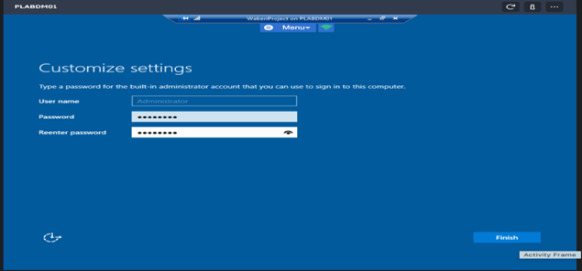

After setting the password, Login with your password.

* **Create a Domain Controller**

After Login the Administrator Account

From **Server Manager Dashboard**window, click **Manage**menu and select **Add Roles and Features.**

The **Before you begin** window opens, click **Next.**

The **Select installation type** window opens, choice **Role-based or feature-based installation** than click **Next.**

The **Select destination server** window opens, choice **Select a server from the server pool** than click **Next.**

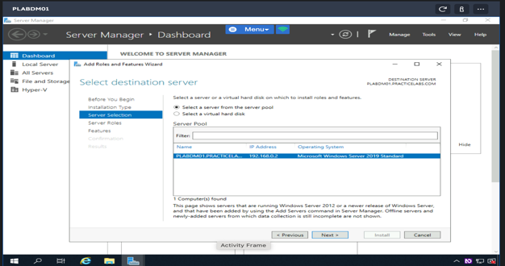

The **Select server roles** window open, Selected **Active Directory Domain Services** then **Add Features** and Selected **DNS Server** then **Add Features,** click **Next**.

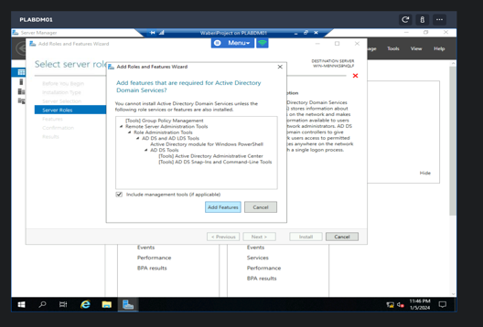

The **Select Features** window open, Verify **the Group Policy Management** is selected then click **Next.**

The Active Directory Domain Service window open, click **Next.**

The **DNS Server** window open, click **Next.**

Confirmation **Installation selections** window open, click **Install.**

When the Installation finish, click close.

Click on the **Notification** then click **Promote this server to a domain controller**.

On the **Deployment Configuration** window opens, Selected **Add a new Forest**, On **Root domain Name** I named **Waberi.pri,** click Next.

**Domain Controller Options** window open, set a **password** and **Confirm password** then click **Next.**

**DNS Option** window open, click **Next.**

**Additional Options** window open, verify the **NetBIOS name** assigned to the domain then click **Next.**

**Paths** window open, click **Next.**

Review Option window open, click Next.

**Prerequisites Check** window open, click **Install.**

When the Installation finish, the system is restart then Login the account.

* **Create the OU, GROUPS, USERS and Computers on the AD Domain.**

From **Server Manager Dashboard**window, click**Tools**menu and select **Active Directory Users and Computer.**

**Active Directory Users and Computer** window open, Right-click **WABERI.pri**, select **New** then select **Organizational Unit** to create OU**.**

**New Object – Organizational Unit** window open, on **Name** prompt type any OU name you want to create then Enable **Protect container from accidental deletion**, click **OK.**

**Active Directory Users and Computer** window, Right-click **Sales**, select **New** then select **Group** to create Group Users**.**

**New Object – Group** window open, on **Group name** prompt type any group name you want to create then Choice the **Group scope** and **Group type**, click **OK**

**Active Directory Users and Computer** window, Right-click **Users**, select **New** then select **User** to create a User**.**

**New Object – User** window open, on **First name** and **Last name** prompt type any user name you want then create **User logon name**, click **Next.**

Set a **Password** and **Confirm Password,** Enable **Password never expires**, click **Next.**

Click **Finish** then the User account **“Rooster Bob”** is created.

* **There is all the Organization Unit requested:**

* **There is all Group Users on Sales requested:**

* **There is all Group Users on CS requested:**

* **There is all Group Users on HR requested:**

* **There is all Group Users on IT Services requested:**

* **There is all the Users and their privileges has requested:**

* **There is the Computer requested:**

